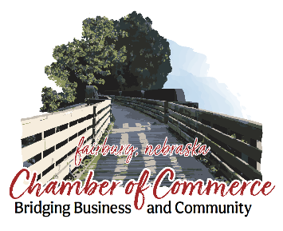

*Fairbury Chamber News*



**May 2024**

**2005 Chamber Membership Directory**

The 2005 Directory is scheduled to be published in April.usiness listing that was mailed February 10. If you haven’t already please pay your Chamber Membership Dues by **March 15** to be included in the Chamber Directory.



**Please help promote the Jefferson County events by *posting flyers* in the newsletter and sharing the newsletter with**

**co-workers and your employees. Remember your employees are Chamber members too.**

**Thank you, Sharon Priefert, Executive Director**

**To add your event, email your info or flyer to:** [**sharon@fairburychamber.org**](mailto:sharon@fairburychamber.org)

# **MAY 3 Cinco DeMeow Taco & Nacho Bar,** 11am-1:30pm, Bonham Theatre. Free Will Donation suggested $8. Proceeds to Homeless No More Cat Rescue. **4 Jayhusker Races**, 7pm, Hot Laps 6:30pm. Concessions by Optimist Club. Ice Cold Beer by Side Trek Bar & Grill. Next races June 8th & 22nd **\*6-10** **2nd Tanniversary** at Rustic Edge Tanning and Salon, 410 E St., you’re invited to celebrate with them. Specials, goodie bags, drawings all week.

# **\*6 Fundraising Car Show Pre-registration. Show May 19.** Registration $15 thru today and then $20. 402-729-6848 / [wayne.franzen@jchealthandlife.org](mailto:wayne.franzen@jchealthandlife.org).

# **\*7 Equine Tai Chi**, helps improve mental health by reducing stress, anxiety, depression and by increasing self-esteem. Every Tuesday in May & June at 7pm. <https://whisperingacres.org>

# **\*9 Spring Salad Festival**, 11-1pm, Elks Lodge, Advance Tickets $9. Door $10

# **\*13 Fairbury Library Summer Reading,** sign up begins today thru May 24. **\*18 AVE Free Shredding Event**, 9-11am, Rays Parking Lot., Northside. Sponsored by AVE Wealth Management and **NJN Financial Group**

# **18 FREE Fishing Day** for all ages. No license required. Crystal Springs Campground and Alexandria State Lakes (Park Permit Required)

# **19 Fundraising Car Show,** 12-3pm, West of Gardenside. No admission for public to attend. Baked Goods, a raffle, t-shirts for sale, concessions for sale.

# **21 Grief Support Group**, 1:30pm. Fairbury Clinic Conference Room every Tuesday. RSVP to Cottonwood Hospice 402-228-8501.

# **23 Suicide Prevention Training,** 9-10:30am, JCH&L Conference Room.

# **27 Memorial Day. Chamber office is closed.**

# **JUNE**

# **\*1 Nebraska Rod & Custom Association’s Tour Nebraska,** Breaking 9am-10:30, Break at Downtown Square. Welcome with Refreshments, Snacks for Free Will Donation & tips. 400-500 cars in 2 groups. [www.nrcawildapricot.org](http://www.nrcawildapricot.org)

# **\*1 Faith Horse Camp, Register** $130/pp. [**www.whisperingacres.org**](http://www.whisperingacres.org)

# **1-2 Rock Creek Station Trail Days,** 9am Reenactments, Entertainment, Buffalo Stew Cookout 7pm. Advance Tickets will be sold at the Chamber office & Rock Creek Station Historical Park. Park Permit Required. **1-2 Steele City Ride In Bike Show,** Sat only, Entertainment all weekend. \***8 Run Roll Adventure Race,** Registration 8am. JCH&L Burkley Fitness Center $60pp. Waiver Enclosed. Registration by May 10th to receive a t-shirt. 13-15 **127th Annual Diller Picnic,** Complete list of events: [www.dillerpicnic.net](http://www.dillerpicnic.net)

# **FARMERS MARKET,** 9am EVERY SATURDAY. Conrad Park 4TH & D St.

# **TACO TUESDAYS,** Doors open @ 4. Tacos 5pm-gone. VFW Post 3113

# **BONHAM THEATRE,** Showing movies Fri-Sat @ 7pm, Sun @ 2pm. $5.00/pp Current showings [www.BonhamTheatre.org](http://www.BonhamTheatre.org)**. Volunteers needed:** Visit [bonhamtheatre.org/volunteer](http://bonhamtheatre.org/volunteer)  Contact [bonhamvolunteer@gmail.com](mailto:bonhamvolunteer@gmail.com). .***\* More information included in newsletter or*** [www.***FairburyChamber.org***](http://www.FairburyChamber.org)

**Chamber Ribbon Cutting for new businesses!**

**Farmers Union Midwest Agency, Lacey Lange**520 C St.](mailto:llange@fumainsurance.com)

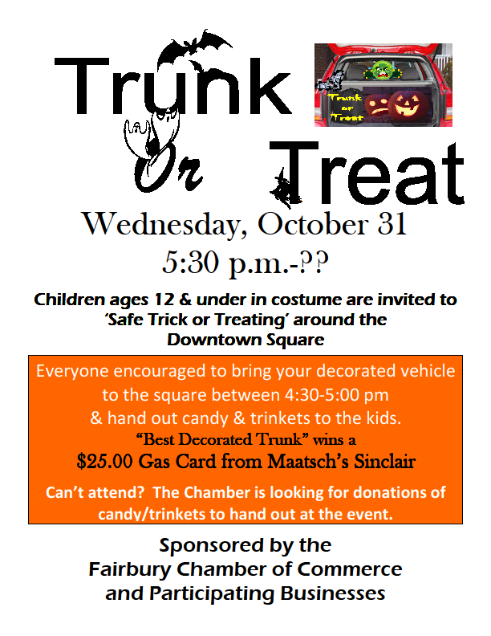



Your text here

Your text here



The Fairbury Chamber of Commerce does not promote or endorse any particular business or organization.are happy to print advertisements and flyers about promotions or events as they are provided to us and according to our price guidelines. Non-member and promotional flyers are accepted but are subject to a fee and board approval. Member contributions which are of a nature other than promotion may be subject to board approval. Political advertising and promotion is not accepted.

**Ziggi’s Coffee, 14th & K, Fairbury NE 68352**

**Owners: Ryan Rippe & Courtney Skoog**

**NINE & WINE GOLF TOURNAMENT  
*FRIDAY, JULY 26 ~ Fairbury Country Club***

**9 Hole ~ 4 Person Scramble  
*Sponsored by Fairbury Chamber of Commerce***

**\*REGISTRATION & SPONSORSHIP OPPORTUNITIES ENCLOSED\***

**Annual Pork N Pints Beer & Wine Tasting Festival**

**Thank you to everyone who came out and enjoyed our 13th Annual Pork N Pints! Big thank you to Totally Smoked BBQ for donating their time to smoke the pork and the specialty beans, to the VFW Post #3113 for hosting the event and our Distributors Ray’s Apple Market (Johnson Bros., Republic National & Southern Glazers) along with**

**Eagle Distributing & K&Z Distributing.**

The Fairbury Chamber of Commerce does not promote or endorse any particular business or organization. We are happy to print advertisements and flyers about promotions or events as they are provided to us and according to our price guidelines. Non-member and promotional flyers are accepted but are subject to a fee and board approval. Member contributions which are of a nature other than promotion may be subject to board approval. Political advertising and promotion is not accepted.

**SEE PAGE 2**